# JS Advanced Final Exam

# Problem 1. Music Site

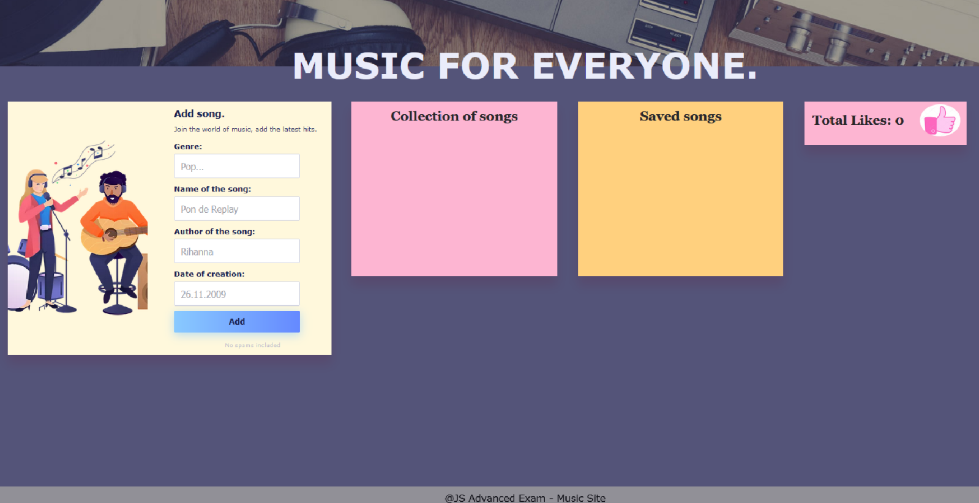

**Your Task**

**Write the missing JavaScript code** to make the **Music Site** work as expected:

* A**ll fields (genre, name, author, and date)** are **filled with the correct input**
  + **Genre, name, author, and date** are **non**-**empty** **strings**
* The program should not do anything if any of the input fields are empty.

1. 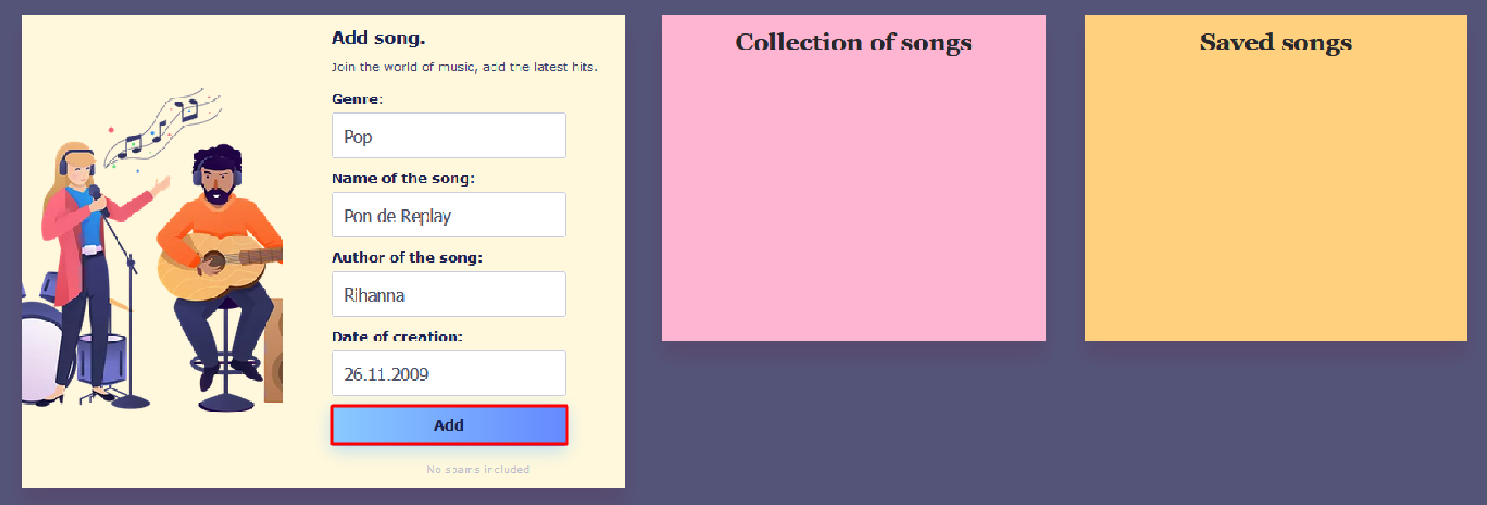**Getting the information about a new song**

* 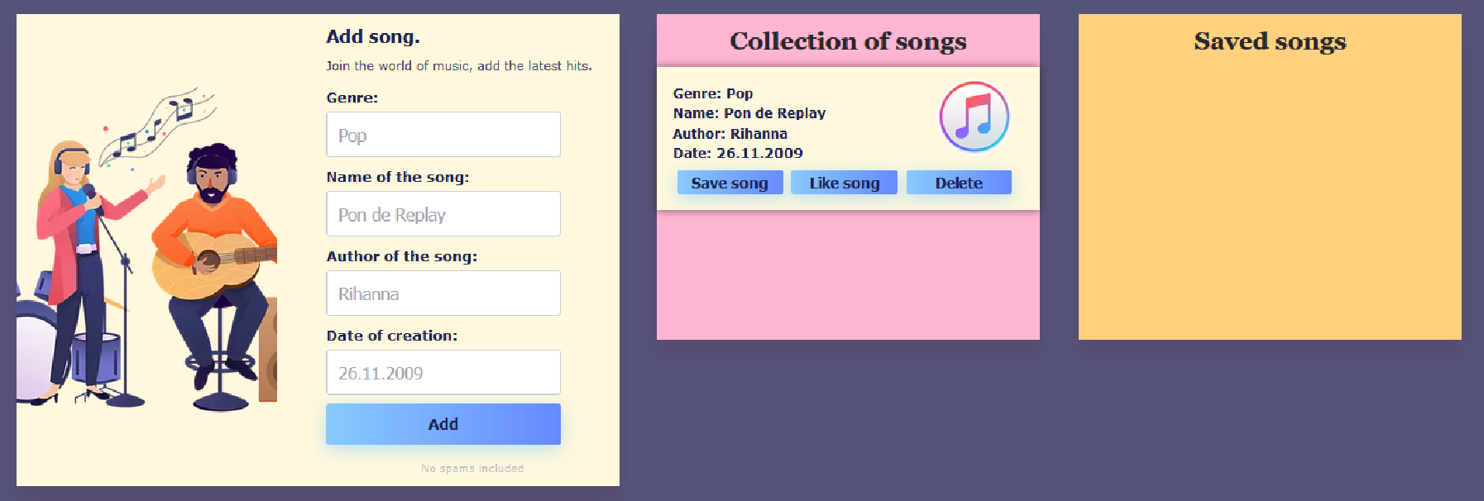When you click the **["**Add**"**] button, the information from the input fields must be added to the **div** with the **class** **"all-hits-container"** and then clear input fields.
* The HTML structure looks like this:

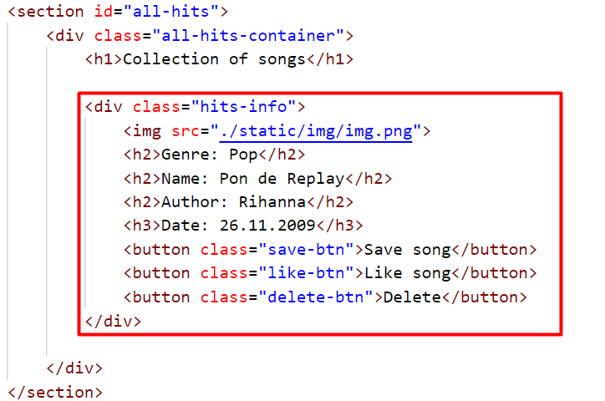

* 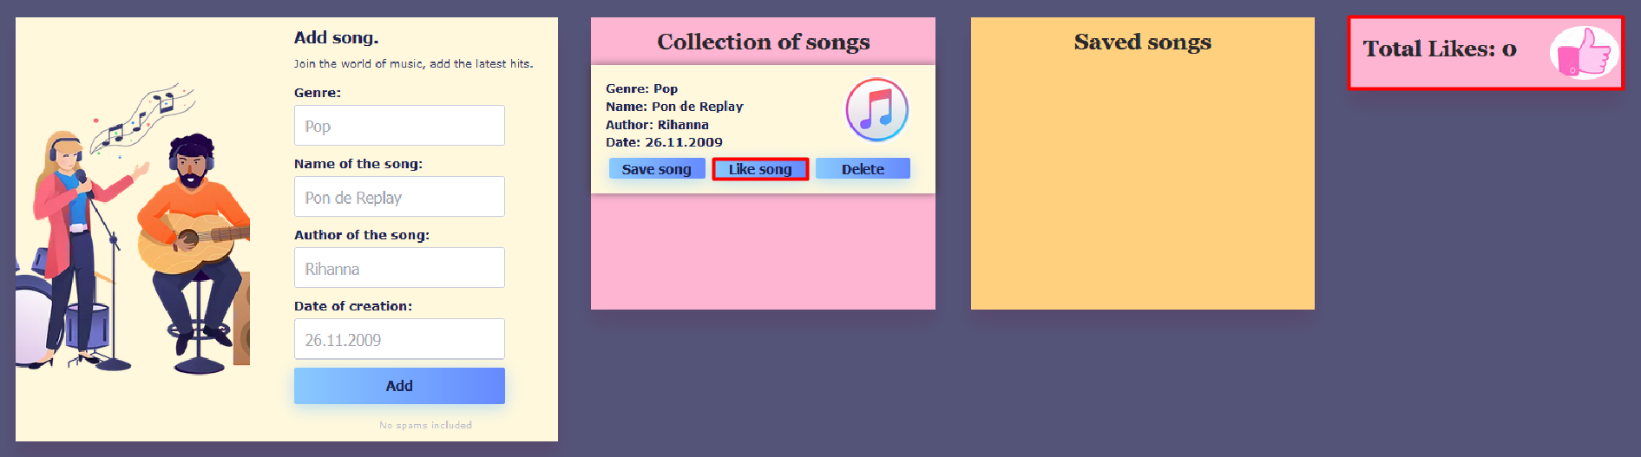When the **["**Like song**"**] button is clicked:
  + 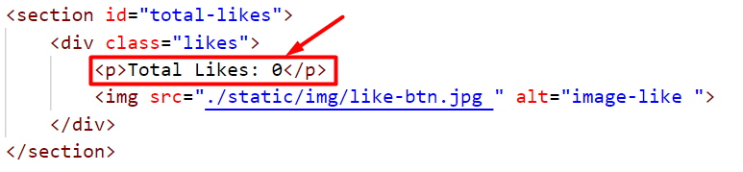You need to take a value of the current number of **likes** inside the paragraph in the section with the id **"total-likes"** and increase the value by one.
  + 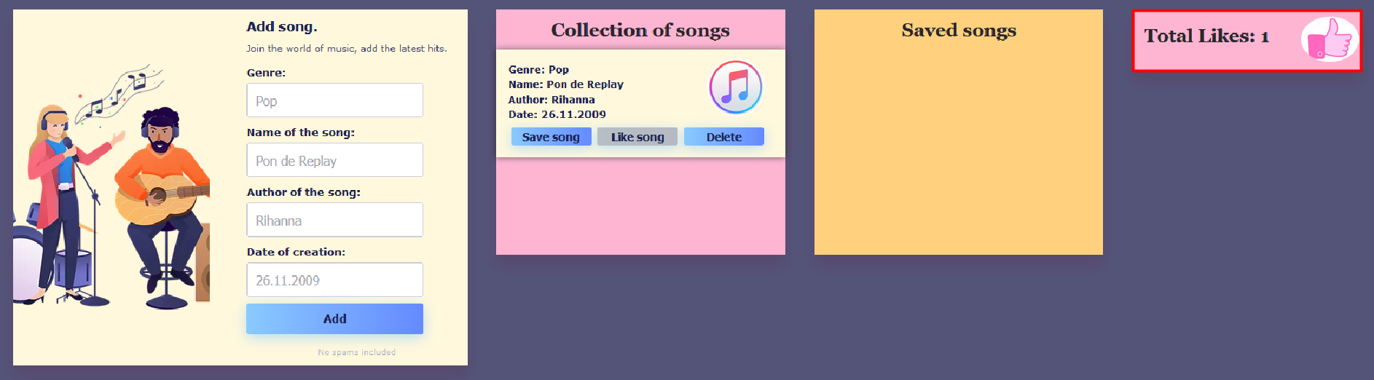The button **["**Like song**"**] for the current song must then be **disabled**, as the user has the right to like the song only once (Once the button is **disabled**, its color will turn gray).

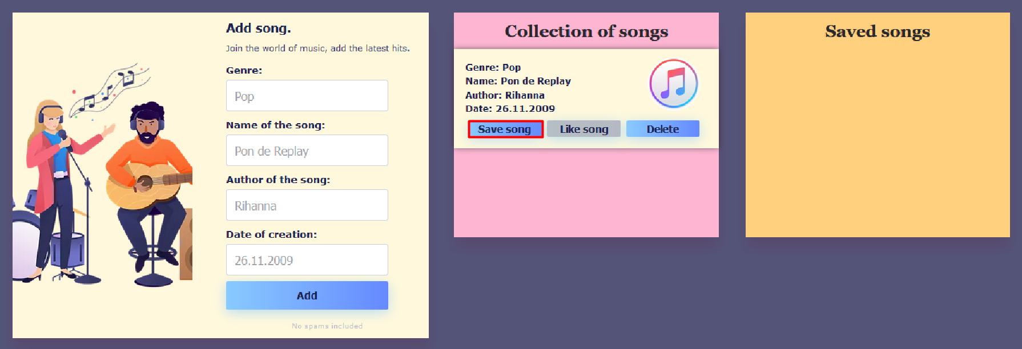

* 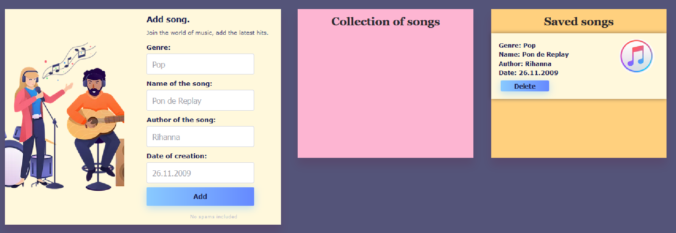When the **["**Save song**"**] button is clicked, you need to move the current song in the **div** with **class** **"saved-container"**.
* The HTML structure looks like this:

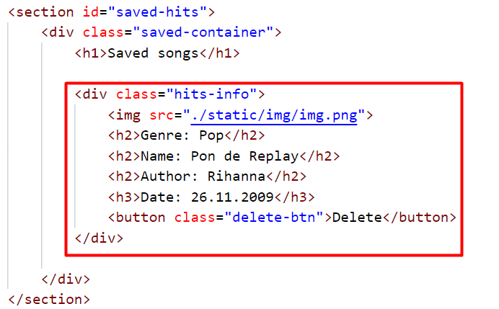

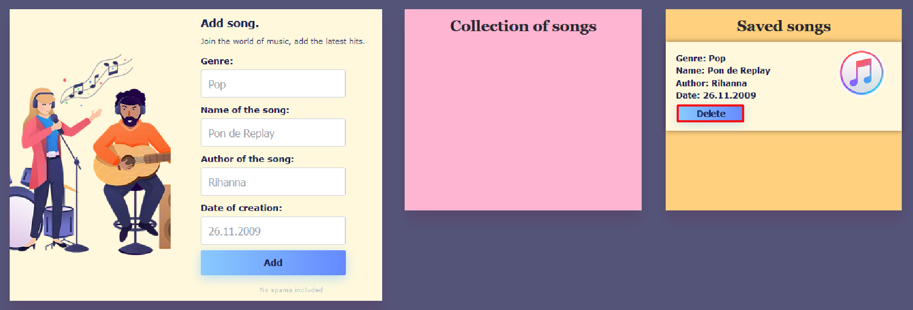

* When you click the **["**Delete**"**] button, the song should be removed from the current section.

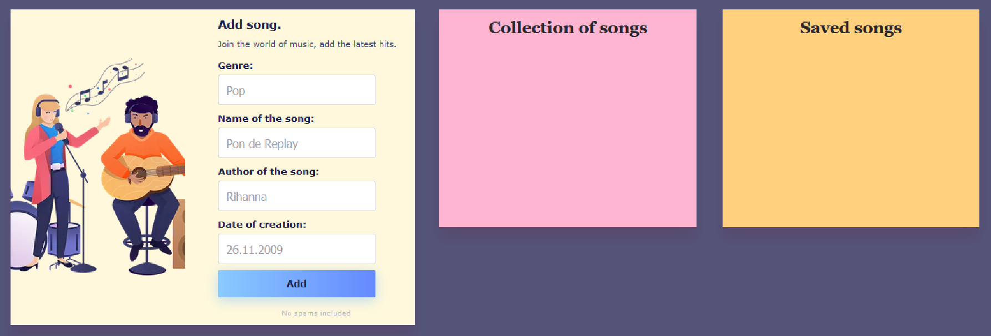**Note:** When deleting a song, you should not reduce the value of the current number of likes.

* 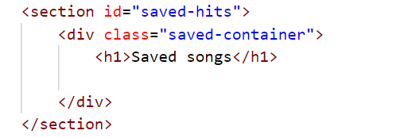The HTML structure looks like this: